Numerical Quantifiers

🔢 What Are Numerical Quantifiers?
# Source: AI Source: Provided by: [Data Path: Persons Table -> ID Column: 1, Name_En Column: Motasem Essam] -> From: [ChatGPT] on [7/28/2025]
Numerical quantifiers are determiners or words that indicate an exact or approximate number or quantity of nouns. They answer “How many?” or “How much?”
They are used with countable nouns (mostly), and are part of quantifiers in grammar.

✅ Types of Numerical Quantifiers
# Source: AI Source: Provided by: [Data Path: Persons Table -> ID Column: 1, Name_En Column: Motasem Essam] -> From: [ChatGPT] on [7/28/2025]
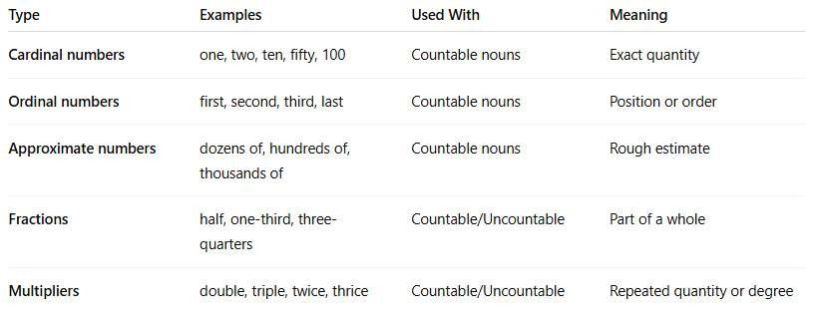
Type | Examples | Used With | Meaning
Cardinal numbers | one, two, ten, fifty, 100 | Countable nouns | Exact quantity
Ordinal numbers | first, second, third, last | Countable nouns | Position or order
Approximate numbers | dozens of, hundreds of, thousands of | Countable nouns | Rough estimate
Fractions | half, one-third, three-quarters | Countable/Uncountable | Part of a whole
Multipliers | double, triple, twice, thrice | Countable/Uncountable | Repeated quantity or degree

🧠 Examples in Sentences
# Source: AI Source: Provided by: [Data Path: Persons Table -> ID Column: 1, Name_En Column: Motasem Essam] -> From: [ChatGPT] on [7/28/2025]
- We saw three lions. (cardinal)
- She came in second place. (ordinal)
- There were hundreds of people. (approximate)
- I drank half the milk. (fraction)
- He earns twice as much as me. (multiplier)

🔁 Related Quantifiers
# Source: AI Source: Provided by: [Data Path: Persons Table -> ID Column: 1, Name_En Column: Motasem Essam] -> From: [ChatGPT] on [7/28/2025]
These can combine with other determiners or adjectives:
- The first few pages were torn.
- Several thousand people attended.
- One or two students were late.

Is Numbers Determiners are same Numerical Quantifiers
# Source: AI Source: Provided by: [Data Path: Persons Table -> ID Column: 1, Name_En Column: Motasem Essam] -> From: [ChatGPT] on [7/28/2025]
Great question!

✅ Short Answer:
# Source: AI Source: Provided by: [Data Path: Persons Table -> ID Column: 1, Name_En Column: Motasem Essam] -> From: [ChatGPT] on [7/28/2025]
Yes — "Numbers determiners" and "Numerical quantifiers" often refer to the same types of words, especially cardinal and ordinal numbers.
However, there’s a small difference in focus depending on context:

🔍 1. Numerical Quantifiers
# Source: AI Source: Provided by: [Data Path: Persons Table -> ID Column: 1, Name_En Column: Motasem Essam] -> From: [ChatGPT] on [7/28/2025]
- Function: Quantify how many or how much.
- Includes:
  - Cardinal numbers: one, two, three
  - Ordinal numbers: first, second, third
  - Approximate numbers: dozens of, hundreds of
  - Fractions / percentages / multipliers
✅ Focus is on amount/quantity (How many? How much?).

🧾 2. Number Determiners
# Source: AI Source: Provided by: [Data Path: Persons Table -> ID Column: 1, Name_En Column: Motasem Essam] -> From: [ChatGPT] on [7/28/2025]
- Function: Specify or determine a noun using numbers.
- Includes:
  - Cardinal numbers (one, two…)
  - Ordinal numbers (first, second…)
✅ Focus is on modifying the noun as a determiner (comes before the noun like: three cats, second row).

📌 Conclusion:
# Source: AI Source: Provided by: [Data Path: Persons Table -> ID Column: 1, Name_En Column: Motasem Essam] -> From: [ChatGPT] on [7/28/2025]
- Overlap: Both include number words like one, two, first, second.
- Difference:
  - If it's used to express quantity, it’s a numerical quantifier.
  - If it’s modifying a noun directly, it’s functioning as a determiner.
So, they are closely related, often interchangeable in simple grammar, but technically:
🔸 All number determiners are numerical quantifiers, but not all numerical quantifiers are strictly determiners.

How not all numerical quantifiers are strictly determiners
# Source: AI Source: Provided by: [Data Path: Persons Table -> ID Column: 1, Name_En Column: Motasem Essam] -> From: [ChatGPT] on [7/28/2025]
Great! Let’s break that statement down step by step for clarity:

🔹 1. Number Determiners = a Subset of Numerical Quantifiers
# Source: AI Source: Provided by: [Data Path: Persons Table -> ID Column: 1, Name_En Column: Motasem Essam] -> From: [ChatGPT] on [7/28/2025]
Number Determiners are words like:
- one, two, three (Cardinal)
- first, second, third (Ordinal)
They are used directly before nouns to specify them:
- Three cats ran.
- She came second.
✅ These are numerical and determine nouns — so they are numerical quantifiers and determiners.

🔹 2. Numerical Quantifiers = a Broader Category
# Source: AI Source: Provided by: [Data Path: Persons Table -> ID Column: 1, Name_En Column: Motasem Essam] -> From: [ChatGPT] on [7/28/2025]
Numerical Quantifiers include:
- Cardinal numbers: one, two, ten ✅ used as determiners
- Ordinal numbers: first, second ✅ used as determiners
- Approximate numbers: dozens of, hundreds of ❌ not strict determiners
- Multipliers: twice, triple, double ❌ not determiners
- Fractions: half, one-third ❌ sometimes determiners
- Percentages: 25%, 10% ❌ not determiners by themselves
Some of these:
- Are not used directly before nouns, or
- Need "of" + noun (e.g., half of the cake, 25% of students)
So they do not function as determiners, even though they quantify.

🔸 So, the key statement explained:
# Source: AI Source: Provided by: [Data Path: Persons Table -> ID Column: 1, Name_En Column: Motasem Essam] -> From: [ChatGPT] on [7/28/2025]
"All number determiners are numerical quantifiers"
✔ Because they quantify and function as determiners.
"But not all numerical quantifiers are strictly determiners"
✔ Because some quantifiers like dozens of, half, 25% do not directly determine a noun the same way.

✅ Final Comparison Table:
# Source: AI Source: Provided by: [Data Path: Persons Table -> ID Column: 1, Name_En Column: Motasem Essam] -> From: [ChatGPT] on [7/28/2025]
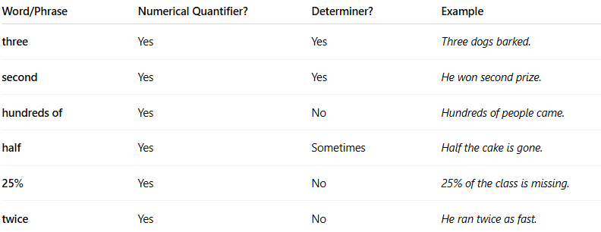
Word/Phrase | Numerical Quantifier? | Determiner? | Example
three | Yes | Yes | Three dogs barked.
second | Yes | Yes | He won second prize.
hundreds of | Yes | No | Hundreds of people came.
half | Yes | Sometimes | Half the cake is gone.
25% | Yes | No | 25% of the class is missing.
twice | Yes | No | He ran twice as fast.

Numbers Determiners vs Numerical Quantifiers
# Source: AI Source: Provided by: [Data Path: Persons Table -> ID Column: 1, Name_En Column: Motasem Essam] -> From: [ChatGPT] on [7/28/2025]
Here’s a clear comparison between Number Determiners and Numerical Quantifiers:

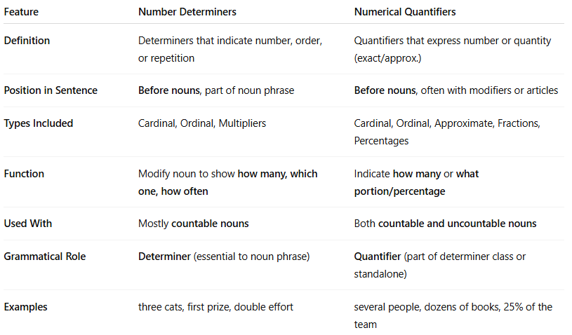
Feature | Number Determiners | Numerical Quantifiers
Definition | Determiners that indicate number, order, or repetition | Quantifiers that express number or quantity (exact/approx.)
Position in Sentence | Before nouns, part of noun phrase | Before nouns, often with modifiers or articles
Types Included | Cardinal, Ordinal, Multipliers | Cardinal, Ordinal, Approximate, Fractions, Percentages
Function | Modify noun to show how many, which one, how often | Indicate how many or what portion/percentage
Used With | Mostly countable nouns | Both countable and uncountable nouns
Grammatical Role | Determiner (essential to noun phrase) | Quantifier (part of determiner class or standalone)
Examples | three cats, first prize, double effort | several people, dozens of books, 25% of the team

✅ Examples Side-by-Side
# Source: AI Source: Provided by: [Data Path: Persons Table -> ID Column: 1, Name_En Column: Motasem Essam] -> From: [ChatGPT] on [7/28/2025]
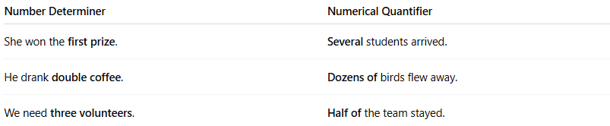
Number Determiner | Numerical Quantifier
She won the first prize. | Several students arrived.
He drank double coffee. | Dozens of birds flew away.
We need three volunteers. | Half of the team stayed.

🔁 Key Difference:
# Source: AI Source: Provided by: [Data Path: Persons Table -> ID Column: 1, Name_En Column: Motasem Essam] -> From: [ChatGPT] on [7/28/2025]
- All number determiners are also numerical quantifiers (they indicate number).
- But not all numerical quantifiers are determiners — some function more flexibly and are not tied to modifying a noun directly.

is three Numbers Determiners or Numerical Quantifiers or both

Answer
# Source: AI Source: Provided by: [Data Path: Persons Table -> ID Column: 1, Name_En Column: Motasem Essam] -> From: [ChatGPT] on [7/28/2025]
The word "three" is both a:
✅ Number Determiner AND ✅ Numerical Quantifier

🔹 Here's Why:
# Source: AI Source: Provided by: [Data Path: Persons Table -> ID Column: 1, Name_En Column: Motasem Essam] -> From: [ChatGPT] on [7/28/2025]
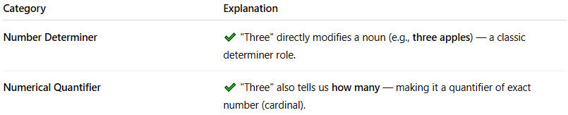
Category | Explanation
Number Determiner | ✔ "Three" directly modifies a noun (e.g., three apples) — a classic determiner role.
Numerical Quantifier | ✔ "Three" also tells us how many — making it a quantifier of exact number (cardinal).

✅ Example:
# Source: AI Source: Provided by: [Data Path: Persons Table -> ID Column: 1, Name_En Column: Motasem Essam] -> From: [ChatGPT] on [7/28/2025]
She has three dogs.
- ✔ "three" is a cardinal number (type of number determiner)
- ✔ It’s also a numerical quantifier (expressing exact quantity)

🔁 Conclusion:
# Source: AI Source: Provided by: [Data Path: Persons Table -> ID Column: 1, Name_En Column: Motasem Essam] -> From: [ChatGPT] on [7/28/2025]
"Three" is both a Number Determiner and a Numerical Quantifier — because:
- It modifies a noun like determiners do
- It expresses quantity like quantifiers do

